**Technical Documentation – Release_Individual_FAR_Artifacts_To_MUAT**

1. Workflow – Releases one or more FAR Artifacts to the MUAT environment. I migrates fmb’s, rdf’s and tif’s (and their corresponding binaries, fmx’s and rep’s).

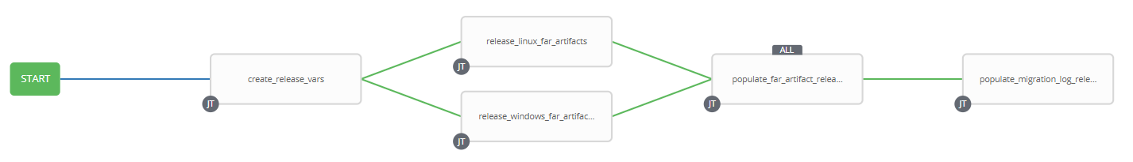

1. Extra Variables defined at the Workflow Level

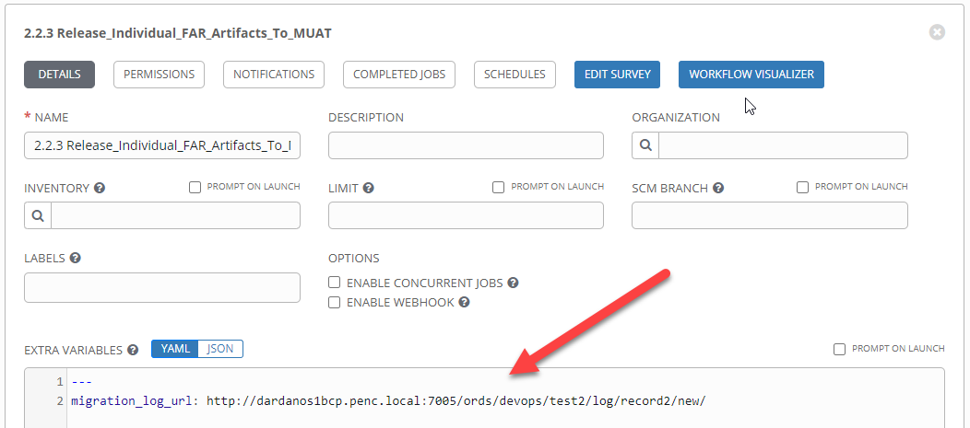

1. Survey – User Supplied Variables

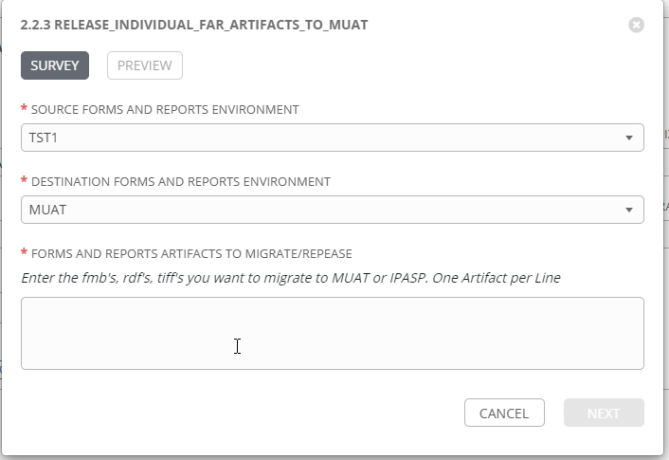

|  |  |  |  |
| --- | --- | --- | --- |
| **Survey Extra Variables** | **Prompt** | **Type** | **Description and Usage** |
| SOURCE | Source Forms and Reports Environment | Multiple Choice Single Pick | Environment to copy FAR Artifacts FROM (TST1, TST2, TST3). |
| DESTINATION | Destination Forms and Reports Environment | Multiple Choice Single Pick | Environment to copy FAR Artifacts TO (MUAT is all that is allowed). |
| FAR_Artifacts | Forms and Reports Artifacts to Migrate/Release | Textarea – 20000 characters | Enter the individual FAR Artifacts (fmb’s, rdf’s or tif’s). Each artifact must be on each own line.  i.e.  Form1.fmb  Form2.fmb  Report1.rdf  Report2.rdf  TIFF1.tif  TIFF2.tif |

1. Jobs Used by the workflow - http://owl.penc.local:18080/svn/deploy_automation/trunk/Ansible_PlayBooks/FAR

| **Job Template** | **Ansible Playbook** | **Credentials / host** | **Project** | **Description and Usage** |
| --- | --- | --- | --- | --- |
| create_release_env_vars | create_release_env_vars.yml | None – runs on localhost as awx linux user | FAR Deployments | Destination_Batch_Compile_Directory: \\cronrepmaint\Reports$\defs\muat  Destination_Online_Compile_Directory: /export_home/codemove/compile/ipas12c/muat  Destination_Online_Runtime_Directory: /opt/ipas_app_test/muat  Destination_WEB_Compile_Directory: /export_home/codemove/compile/ipas12c/webm  Source_Batch_Compile_Directory: \\cronreptest1\Reports$\defs\tst1  Source_Online_Compile_Directory: /export_home/codemove/compile/ipas12c/tst1  Source_Online_Runtime_Directory: /opt/ipas_app_test/tst1  Source_WEB_Compile_Directory: /export_home/codemove/compile/ipas12c/webt  batch_far_server: cronreptest1  date_time: '20201126_0804'  far_server: taras1bcp  open_chmod: false  stage_server: daulis1bcp  tower_hostname: pdeploy1bcp.penc.local |
| release_linux_far_artifacts | release_linux_far_artifacts.yml  calls process_single_linux_far_artifact.yml | Codemove on {{far_server}} typically taras1bcp | FAR Deployments | Release_linux_far_artifacts.yml checks for the existence of {{Destination_Online_Compile_Directory}}, {{Destination_Online_Runtime_Directory}}, {{Source_Online_Compile_Directory}} and {{Source_Online_Runtime_Directory}}.  For each artifact in {{FAR_Artifacts}} process_single_linux_far_artifact.yml checks for the existence it and its corresponding binary in {{Source_Online_Compile_Directory}} and {{Source_Online_Runtime_Directory}}, if they exist copies them to the {{Destination_Online_Compile_Directory}}, {{Destination_Online_Runtime_Directory}} directories. The ansible copy module is used to copy the artifact so checksums are used to ensure data integrity and backups of any existing FAR artifact in the destination directory are created.  Updates {{Online_FAR_Artifacts_Deployed}} with the status of the Artifact. |
| release_windows_far_artifacts | release_windows_far_artifacts.yml  calls  process_single_windows_far_artifact.yml | Penc\ora_cronreptest on {{batch_far_server}} typically cronreptest1 | FAR Deployments | Release_windows_far_artifacts.yml checks the existence of {{Source_Batch_Compile_Directory}} and {{Destination_Batch_Compile_Directory}}. For each artifact in {{FAR_Artifacts}} process_single_windows_far_artifact.yml checks the existence of it and its corresponding binary in the {{Source_Batch_Compile_Directory}} and if they exist copies them to {{Destination_Batch_Compile_Directory}}. The ansible win_copy mudule is used to copy the artifact, so checksums are used to ensure data integrity and backups of any existing FAR artifact in the destination directory are created.  Updates {{Batch_FAR_Artifacts_Deployed}} with the status of the Artifact. |
| populate_far artifacts_release_logs | populate_far_artifacts_release_logs.yml | Codemove on {{stage_server}} typically daulis1bcp | FAR Deployments | If both the release_windows_far_artifacts and release_linux_far_artifacts complete successfully create and populate the /codemove_common/dp_automation/releases/{{DESTINATION}}_{{Release_Date}}/{{DESTINATION}}_Emergency_Release_log.html file. |
| populate_migration_log_release_individual | populate_migration_log_release_individual.yml | Pencmw on pdeploy1bcp/pdevops1bcp | FAR Deployments | Populates the migration log via the APEX/ORDS migration log URL defined with {{migration_log_url}} |